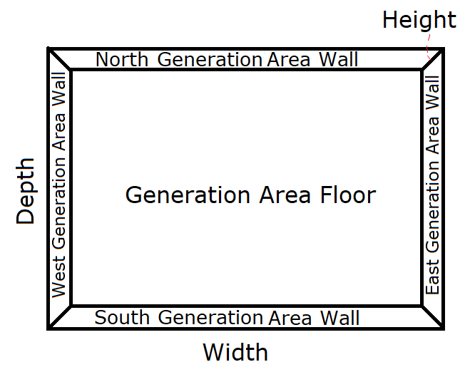Another example of its use, is detailed in this section. Note that no matter which algorithm is used to fill the area, the set-up shown immediately below, is always used, before the space is filled with the respective space-filling algorithm:

The width and depth for this area, are expressed by the user (in cm). This will encapsulate the volume to generate a level within (filling space from the ‘Generation Area Floor’, to the default height of the level (100cm or 1UU).

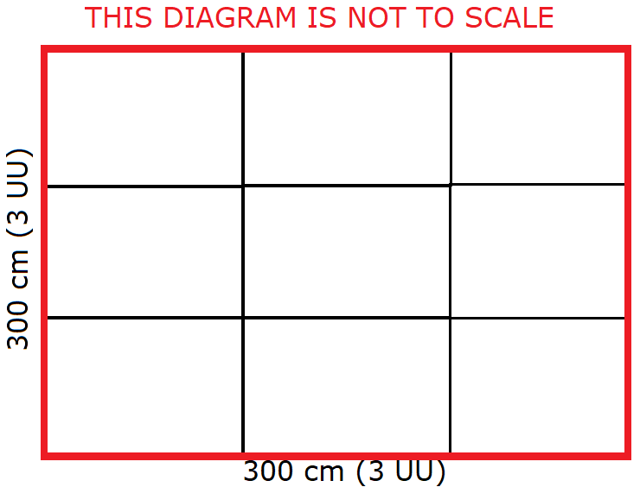For the use of Wang Tiles, each Wang Tile (Zone class instance) in this implementation, will take up a volume of 1m3 (1x1x1 UU). Specifically, as shown in the diagram immediately to the right, is this set-up for the placement of these Zones (for a 3x3m area (9UU2)):

As there are walls encompassing this area, they are presumed to have a red-edge (matching up to the tiles).

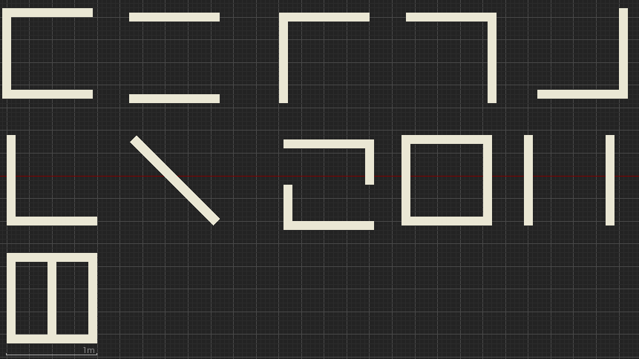A top-down view (to scale), of all the Wang Tiles in the set, is provided below:

There are 11 Wang Tiles in this set used by the level-generator. The anchor point of each object on the tile is 5 cm from the edge of this object (given that the width of the objects for each Wang Tile, are to each other). The calculations of the edge-colour, for each of the edges of each wang tile, is provided below (starting at the top left of the above diagram, for WangTile1, moving rightwards for the next Wang Tile, on a row by row basis, with the ranges for the edge-colour as: Where if $0≤δ_{j}≤2500, then {Edge}_{COLOUR}=Grey. If 2500<δ_{j}≤5000, then {Edge}_{COLOUR}=Red. If 5000<δ_{j}≤7500, then {Edge}_{COLOUR}=Green. If 7500<δ_{j}≤100, then {Edge}_{COLOUR}=Blue.$): (Omitted) The Geometry for Zones 9 and 11, allow the Player to pass through them, by (from the west or east to the opposite direction, over the obstacles in the Zone).

These Edge colours, are represented on the diagram of Wang Tiles, as per the calculations, as shown below (along with a number to identify each tile, when mentioned in a text passage of this document):

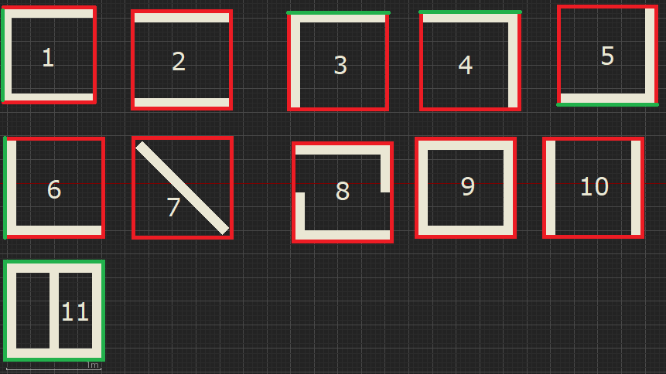As per the example grid layout (shown earlier in this section), these tiles will now be placed onto the grid, making sure that they match up to the edges correctly.

If there is more than one tile available, in the set of sub-tiles, that match the current grid position, a random number will be used to decide on which tile to use from this sub-set. This has been generated by Random.org. (Random.org, 2018)

Placement of tiles will begin on the lowest row of the grid, in the first column, moving rightwards. The colour of the geometry on the tiles, has been changed to black (to have them stand out).

## First Row

First Column: Valid tiles: 2, 3, 4, 7, 8, 9 and 10. Tile chosen: 10.

Second Column: Valid tiles: 2, 3, 4, 7, 8, 9 and 10. Tile chosen: 8.

Third Column: Valid tiles: 2, 3, 4, 7, 8, 9 and 10. Tile chosen: 4.

The generation area, after selecting tiles for the first row, is shown to the left:

## Second Row

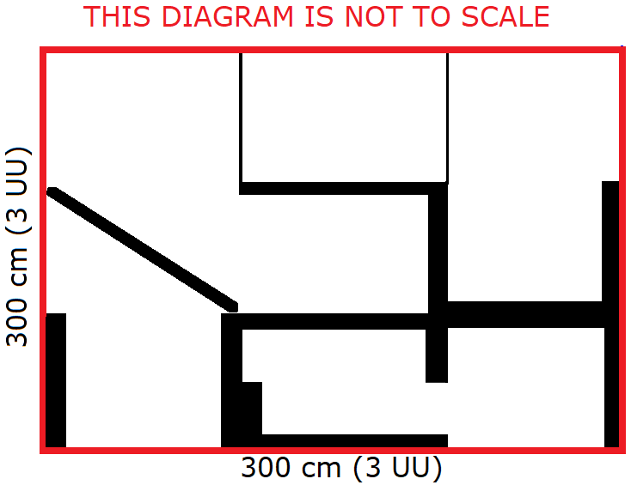First Column: Valid tiles: 2, 3, 4, 7, 8, 9 and 10. Tile chosen: 7. Second Column: Valid tiles: 2, 3, 4, 7, 8, 9 and 10. Tile chosen: 4. Third Column: Valid tiles: 5. Tile chosen: 5. The generation area, after selecting tiles for the second row, is shown to the right:

## Third Row

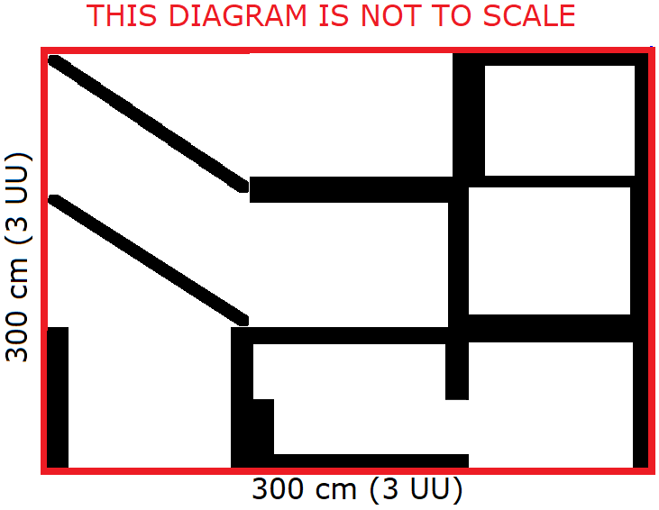First Column: Valid Tiles: 2, 7, 8, 9 and 10. Tile Chosen: 7. Second Column: Valid Tiles: 5. Tile Chosen: 5. Third Column: Valid Tiles: 2, 7, 8, 9 and 10. Tile Chosen: 9. The generation area, after selecting tiles for the third column, is shown to the right:

After completing these sample calculations, it has become clear that the equation for determining the edge-density of a Zone’s Edges, provides inconsistent values. This can result in output, as is shown, in the diagram to the right. This shows a level, where the Player is not able to move between all the Zones, no matter where their Spawn Point is placed in the level. Modifications to the Edge Colour calculations, will have to be undertaken to resolve this issue. Heuristics will be considered for this along with reconsidering the tile design (as in this example, the 11th tile will have never been considered, as there is no configuration of tiles that would allow for the placement of it).

# References

RANDOM.ORG, © 1998-2018. *What’s this fuss about true randomness?* [Viewed on the 18/03/2018]. Available from: <https://www.random.org/>